NAMA: Pradana Argo Pangestu

NIM:2311104079/SE-07-02

LAPRAK MODUL 5 PRAKTIKUM ARSITEKTUR&DESAINPERANGKATLUNAK

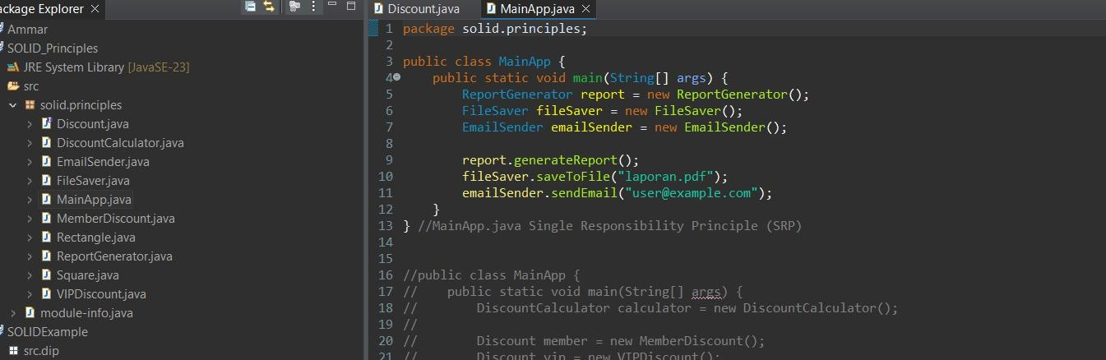

Discount.java

publicinterfaceDiscount{

doubleapplyDiscount(doubleprice);

}

Ini adalah **interface** untuk menerapkan diskon.Class lain akan mengimplementasikan metode applyDiscount.

**Prinsip yang digunakan:** Interface Segregation Principle(ISP).

# MemberDiscount.java

publicclassMemberDiscountimplementsDiscount{ public double applyDiscount(double price) {

returnprice* 0.1;

}

}

Implementasi diskon untuk **member biasa**(10%).

# VIPDiscount.java

public class VIPDiscount implements Discount { publicdoubleapplyDiscount(doubleprice){

returnprice* 0.2;

}

}

Implementasi diskon untuk **VIPmember**(20%).

# DiscountCalculator.java

publicclassDiscountCalculator {

publicdoublecalculateDiscount(Discountdiscount,doubleprice){ return discount.applyDiscount(price);

}

}

Kalkulator diskon yang menggunakan **polimorfisme**.

✅Mengikuti **Open-Closed Principle(OCP)**—kita bisa menambahkan jenis diskon baru

**Tanpa mengubah** class ini.

# ReportGenerator.java

public class ReportGenerator { publicvoidgenerateReport(){

System.out.println("Membuatlaporan...");

}

}

Khusus hanya untuk membuat laporan.

✅Mengikuti **Single Responsibility Principle(SRP)**.

# FileSaver.java

publicclassFileSaver{

public void saveToFile(String filename) { System.out.println("Menyimpanlaporanke"+filename);

}

}

Menyimpan laporan kefile.

✅Juga sesuai **SRP**,tugasnya hanya satu.

# EmailSender.java

publicclassEmailSender{

public void sendEmail(String email) { System.out.println("Mengirimlaporankeemail:"+email);

}

}

Mengirim laporan lewat email.

✅Juga sesuai **SRP**.

# Rectangle.java

public class Rectangle { privateintwidth,height;

publicRectangle(intwidth,intheight){ this.width = width;

this.height=height;

}

public int getArea() { returnwidth*height;

}

}

Class**PersegiPanjang**,menghitungluas.

✅ Sesuai **Liskov Substitution Principle(LSP)** karena tidak di warisi secara salah oleh persegi.

# Square.java

publicclassSquare{ privateintside;

publicSquare(intside){ this.side = side;

}

public int getArea() { returnside*side;

}

}

Class**Persegi** —tidak mewarisi dari Rectangle, sehingga tidak melanggar **LSP**.

# MainApp.java

Terdapat **3 versi kode** yang menunjukkan implementasi prinsip berbeda:

# ✅ Versi 1–SRP:

publicclassMainApp{

public static void main(String[] args) { ReportGeneratorreport=newReportGenerator(); FileSaver fileSaver = new FileSaver(); EmailSender emailSender = new EmailSender();

report.generateReport(); fileSaver.saveToFile("laporan.pdf"); emailSender.sendEmail("[user@example.com](mailto:user@example.com)");

}

}

# Output:

Membuatlaporan...

Menyimpanlaporankelaporan.pdf

Mengirimlaporankeemail:[user@example.com](mailto:user@example.com)

# ✅ Versi 2–OCP:

publicclassMainApp{

publicstaticvoidmain(String[]args){

DiscountCalculatorcalculator=newDiscountCalculator();

Discountmember=newMemberDiscount(); Discount vip = new VIPDiscount();

doublememberPrice=calculator.calculateDiscount(member,1000); double vipPrice = calculator.calculateDiscount(vip, 1000);

System.out.println("DiskonMember:"+memberPrice); System.out.println("Diskon VIP: " + vipPrice);

}

}

# Output:

Diskon Member:100.0

Diskon VIP:200.0

# ✅ Versi 3–LSP:

publicclassMainApp{

public static void main(String[] args) { Rectanglerectangle=newRectangle(5,10); Square square = new Square(5);

System.out.println("LuasPersegiPanjang:"+rectangle.getArea()); System.out.println("Luas Persegi: " + square.getArea());

}

}

**Output:**

